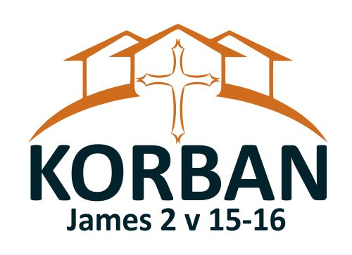
Colchester Korban Project
Reg. Office: Bethany Place St Anne’s Vicarage
Compton Road,
Colchester, CO4 0BQ

www.korban.org.uk
Tel: 01206 869533

Please complete this form and return directly to COLCHESTER KORBAN PROJECT at the address above (not your bank). We will send it to your bank for you. Or email it to: korban.manager@outlook.com
Standing Order mandate

To……………………………………………………………………………………………………………………………………………
(Name of your bank or building society)

Address………………………………………………………………………………………………………………………………………………………………………………………………………………………………………………………………………………………………………………………………………………………………………. Post Code ………………………………………

My Account Number…………………………………………….. Sort Code ………. /………. /……….

Please pay to: Colchester Korban Project, Bethany Place, St Anne’s Vicarage, Compton Road, Colchester CO4 0BQ
Bank account: 65304628 Sort Code: 08 – 92 – 99

Amount £ : ……………………………………………. Amount in words: …………………………………………

Commencing on ………………………………… On the ……………………………… day of……………………………… (Month)…………………………..(Year)
And continue to take this sum ever Week/month/quarter/year (delete as appropriate) until further notice.

Please take this as instruction to set up a standing order from my account and to replace any other ongoing payment to the same organisation

Signed ………………………………………………………………………. Date: / /
Name (printed)…………………………………………………………..

Charity Gift Aid Declaration – multiple donation
Boost your donation by 25p of Gift Aid for every £1 you donate Gift Aid is reclaimed by the charity from the tax you pay for the current tax year. Your address is needed to identify you as a current UK taxpayer

In order to Gift Aid your donation you must tick the box below:

I want to Gift Aid this donation of £………………………. (amount) and any donations I make in the future or have made in the past 4 years to Colchester Korban Project. I am a UK tax payer and understand that if I pay less Income Tax and/or Capital Gains Tax than the amount of Gift Aid claimed on all my donations in that tax year it is my responsibility to pay any difference.

Name of Charity ____________________________________________________________

My Details

Title ____________________ First name or initial(s) ________________________________
Surname ___________________________________________________________________________

Full Home address ___________________________________________________________________________
___________________________________________________________________________
___________________________________________________________________________
Postcode __________________________ Date ____________________________________

Please notify Colchester Korban Project if you:
- want to cancel this declaration
- change your name or home address
- no longer pay sufficient tax on your income and/or capital gains

If you pay Income Tax at the higher or additional rate and want to receive the additional tax relief due to you, you must include all your Gift Aid donations on your Self-Assessment tax return or ask HM Revenue and Customs to adjust your tax code.

Thank you very much for your support

